Final Project Screenshots

**Step 1 - Data Collection:**

Install OpenCV



Run the data collection jupyter notebook

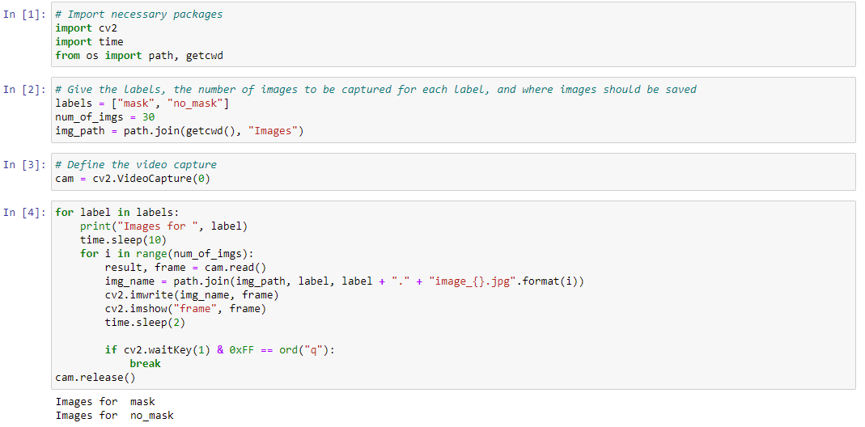

images folder has two folders in it, mask and no_mask

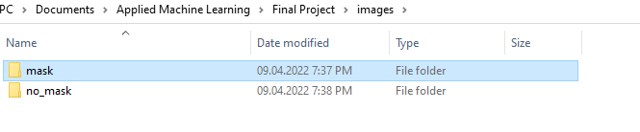

Contents of mask folder

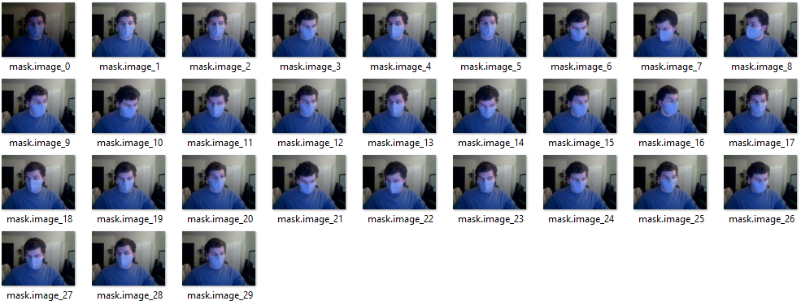

Contents of no_mask folder

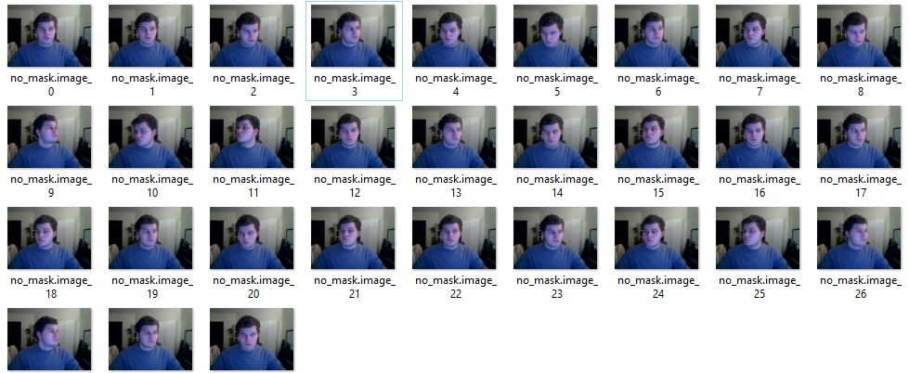

**Step 2 - Labelling**

Install tensorflow

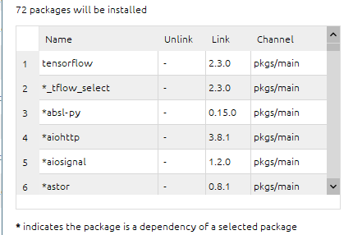

Install pyqt 5

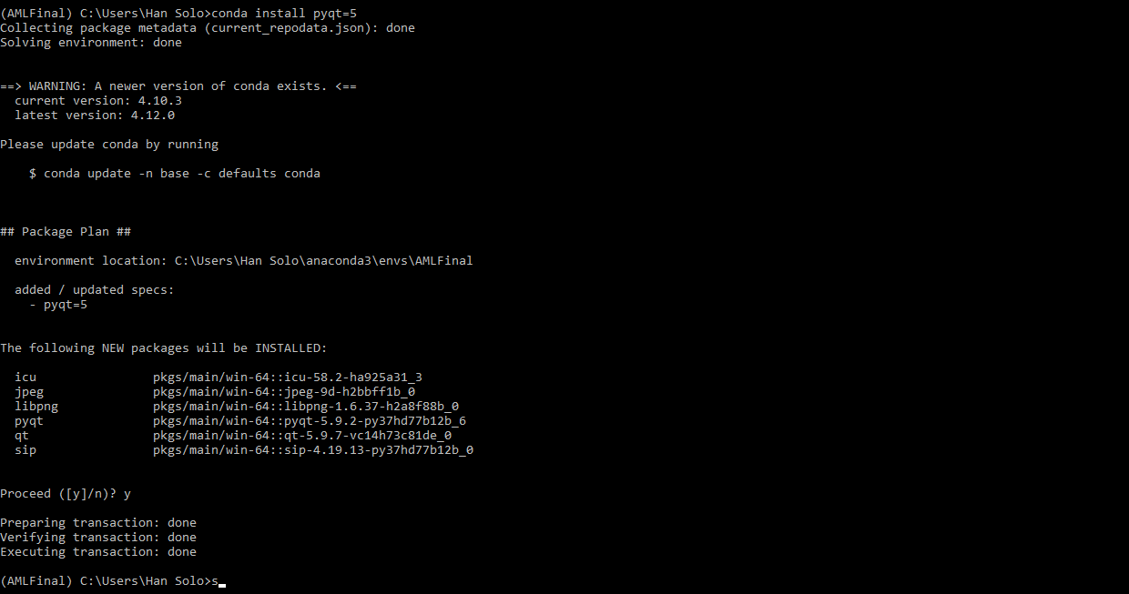

Install lxml



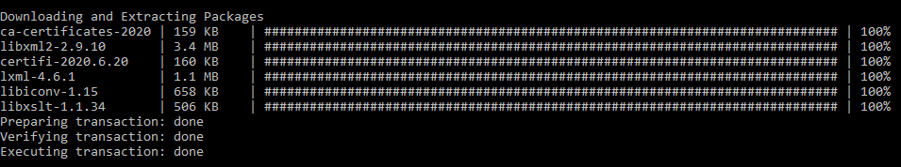

Download labelImg files from GitHub and place in Documents folder

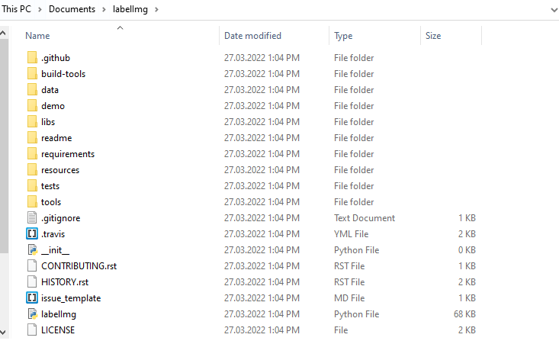

Move to the labelImg directory, and create the resources.py file



Run labelImg.py, and label the data



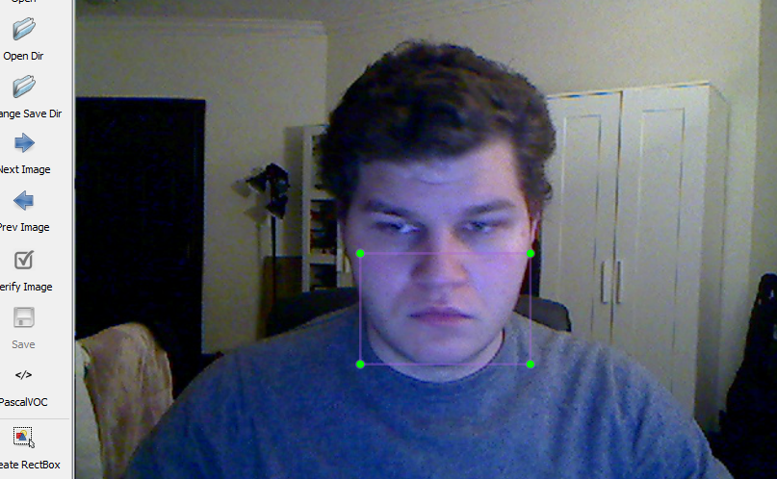

Contents of annotations (where the labellings are saved) folder

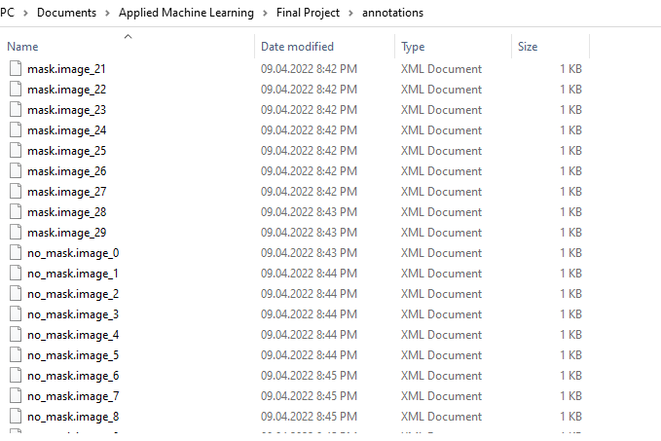

Example of labelling file

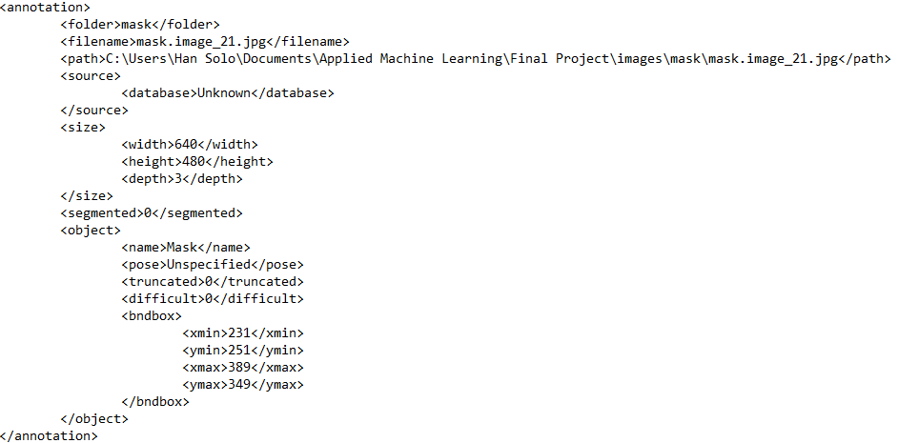

**Step 3 - Using TensorFlow Object Detection API:**

Copying files from TensorFlow Model Garden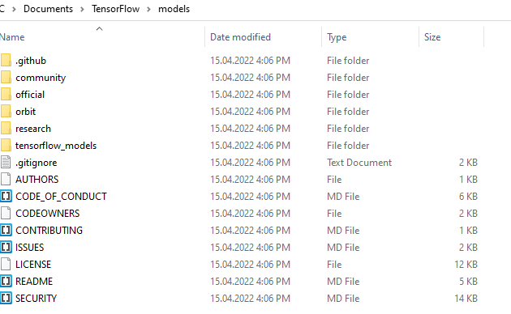

Running protoc command in research folder



Installing COCO API

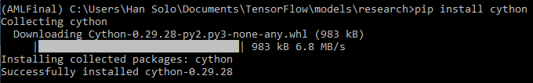

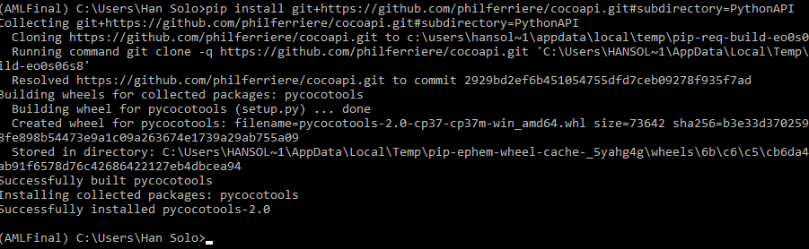

Installing Object Detection API

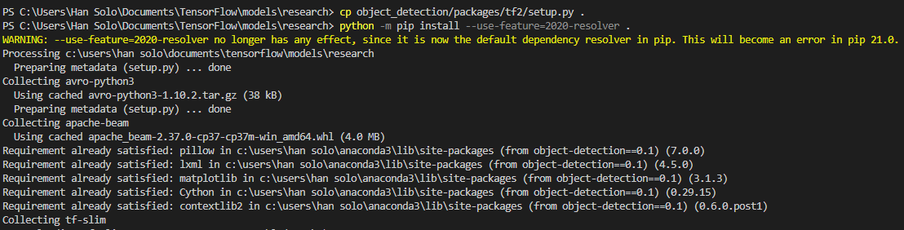

Testing Object Detection

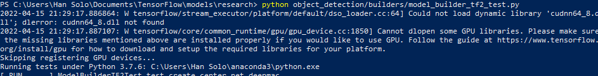

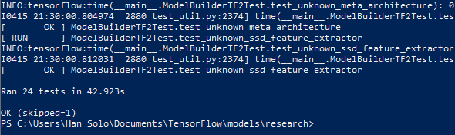

Split data into train and test sets by taking every 4 samples from mask and no_mask

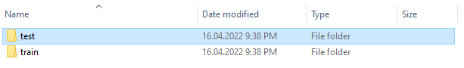

Train set Test set

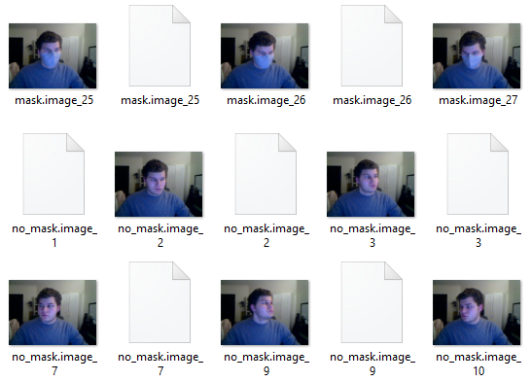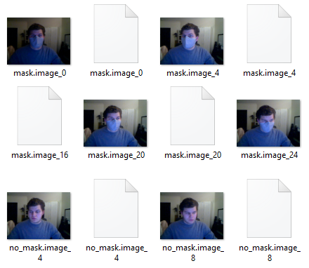

Make change to main function in xml_to_csv as needed

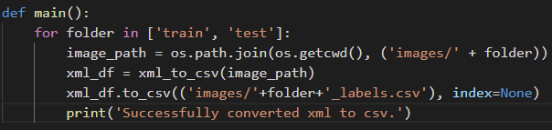

Run xml_to_csv file

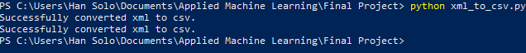

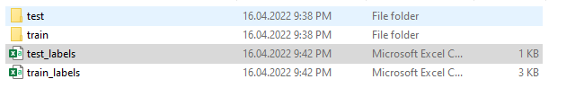

Make changes to class_text_to_int function in generate_tfrecord as needed

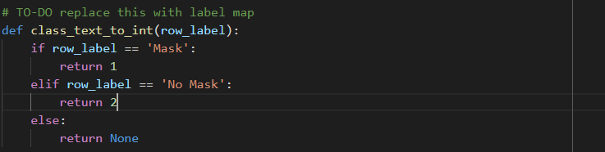

Run generate_tfrecord on both train and test labels files

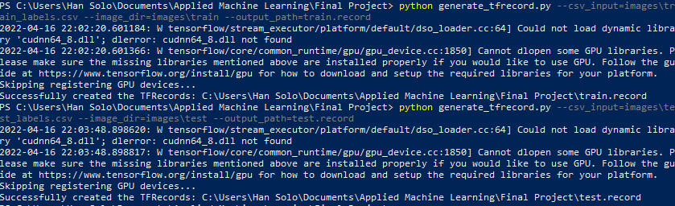

Sort folders for training

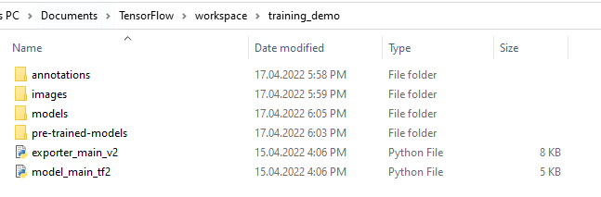

Made changes to config file







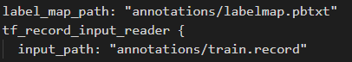

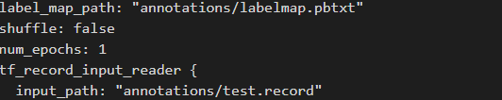

Training the model

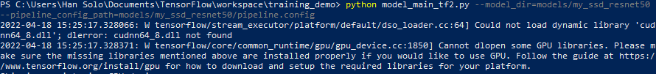

Exporting the model

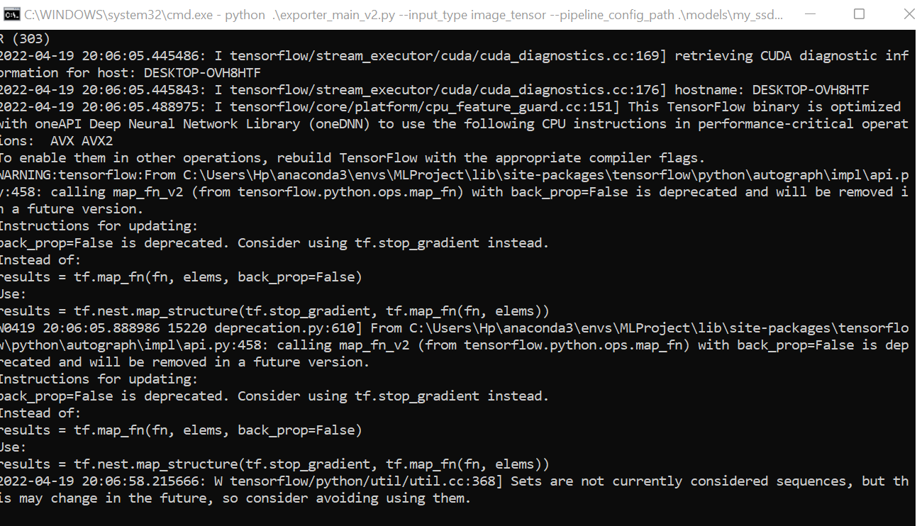

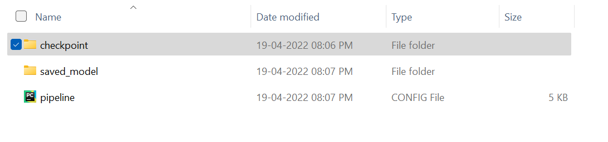

Tensorboard

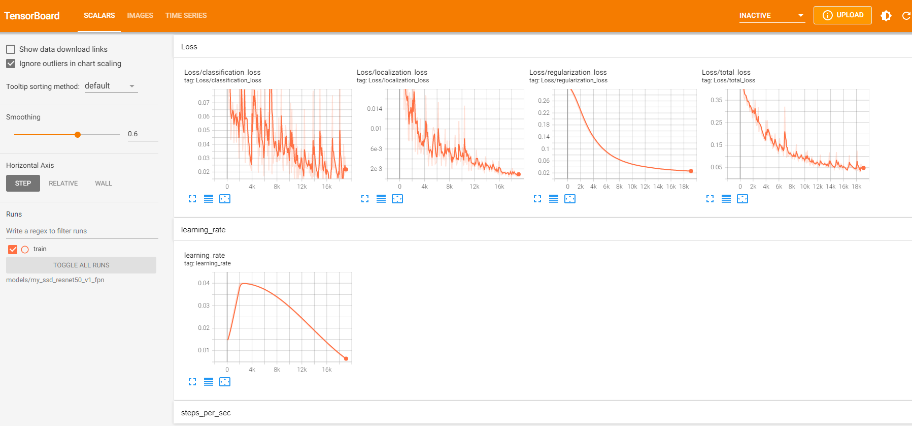

Real-time prediction

